**Hello World RESTful Web Service**

**Step 1:**

Create a Maven project using the help of <https://start.spring.io/> along with the dependency Spring web.

**Step 2:**

Change the port in the application.properties as:

server.port = 8083

**Step 3:**

Create the java application by create a folder called controller in src / main / java / com / cognizant / spring_learn1 .

And create the HelloController.java in the controller folder.

package com.cognizant.spring_learn1.controller;

import org.slf4j.Logger;

import org.slf4j.LoggerFactory;

import org.springframework.web.bind.annotation.GetMapping;

import org.springframework.web.bind.annotation.RestController;

@RestController

public class HelloController {

private static final Logger LOGGER = LoggerFactory.getLogger(HelloController.class);

@GetMapping("/hello")

public String sayHello() {

LOGGER.info("START");

String message = "Hello World!!";

LOGGER.info("END");

return message;

}

}

**Step 4:**

Run the file as a java application, then go to you browser and click the url:

<http://localhost:8083/hello>

**Output:**

Application turned on:

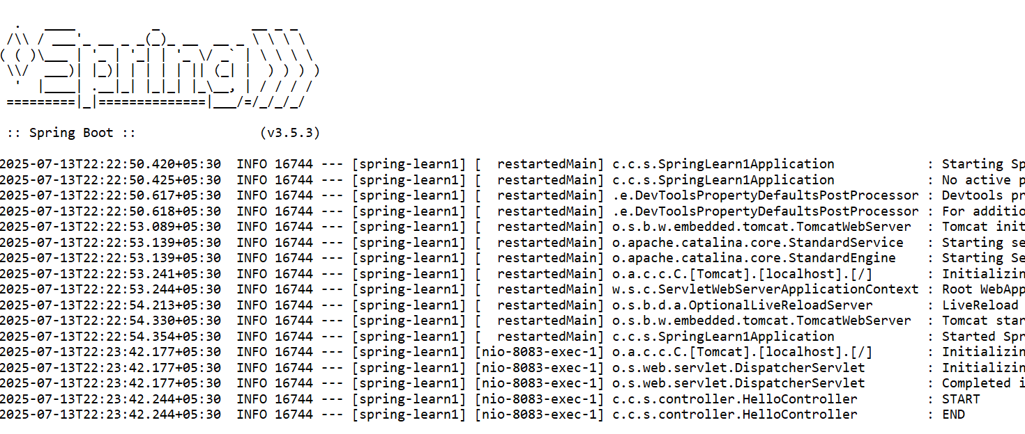

Web page:

